CIS 4130 Big Data Technologies Semester Project

Nguyen Than

Email: [Nguyen.than@baruchmail.cuny.edu](mailto:Nguyen.than@baruchmail.cuny.edu)

Milestone 1 ……………………………………………………………………………..Page 2

Milestone 2 ……………………………………………………………………………..Page 3

Milestone 3 ……………………………………………………………………………..Page 6

Milestone 4 ……………………………………………………………………………..Page 10

Milestone 5 ……………………………………………………………………………..Page 12

Milestone 6 ……………………………………………………………………………..Page 19

Milestone 7 ……………………………………………………………………………..Page 19

Milestone 1

In this project I will be working with data from yelp in which I will perform analysis related to Natural Language Processing and Machine Learning method on the dataset. The dataset that I found is about yelp data. This dataset was sourced from Kaggle.com here I attach the link to the datasets (link: <https://www.kaggle.com/datasets/yelp-dataset/yelp-dataset/versions/3>) the size of the data is about 11GB. The data is in json format, and the data consist of information about the businesses, the reviews, ratings, checking information, tip information, and users’ information as well as other various different data points, the data was separated into different files. The first step I will do is to covert the data from json format to CSV format so I can see the dataframe easier.

In this project I will apply Natural Language Processing methodology in the review data to do sentiment analysis and topic modeling to see how customers feel about these businesses. For sentiment analysis, I will match the reviews and the rating score of the businesses. I will classify negative reviews with rating with a score from 1 to 2, neutral rating for rating with a score of 3 and positive rating for review with a rating score from 4 to 5. I want to see how much percentage of the review data is positive and how much is negative as well as the neutral reviews and what kind of business get the most negative reviews and what kind get the most positive reviews. With topic modeling I want to see the phrase patterns, cluster words and in different businesses what the customers are talking about the most.

Milestone 2

In this milestone I mostly follow the tutorial that was sent for the whole class on how to download data from Kaggle to S3 bucket.

1. First step I created my administrator account and make sure to get the permission is [insert a screenshot] and generated an access key and the password and downloaded the csv which contain the information of the access key and the password.
2. Second step I went to the CIL account and download the command line of aws. I opened the command line in EC2. Using command “aws” and after that type “aws configure” and pasted in the access key, password, time zone us-east-2 and json format as output.
3. To create S3 bucket I use this code from the tutorial document: $ aws s3api create-bucket --bucket project--yelp-review-sentiment-analysis --region us-east-2 --create-bucket-configuration \ LocationConstraint=us-east-2

This code did not work for me so I did abit of research to learn why it is not working after reading this site: [insert page] I change the code to: $ aws s3api create-bucket – bucket project--yelp-review-sentiment-analysis --region us-east-2 --create-bucket-configuration LocationConstraint=us-east-2

1. I installed Kaggle using $pip install Kaggle.
2. Then I generate the API from my Kaggle account to get the Kaggle.json file.
3. In my EC2 instance:   
   - I used this code: $ mkdir .kaggle to make a directory to Kaggle

* After that I used this code: $ nano .kaggle/kaggle.json and paste down the information I got from the Kaggle.json file. Save the information and exit.
* I follow the tutorial and used this code to secure the file : : $ chmod 600 .kaggle/kaggle.json
* I check the cli command of Kaggle using: $ kaggle datasets list

1. After I got my Kaggle datasets list. I follow step 6 in the tutorial to edit the kaggle_api_extended.py

* First I used this code: $ nano ~/.local/lib/python3.7/site-packages/kaggle/api/kaggle_api_extended.py
* Then I navigate line 1582 to change the code from: if not os.path.exists(outpath):

To: if not os.path.exists(outpath) and outpath != "-":

* I navigate to line 1594 and edited the code from: with open(outfile, 'wb') as out:

To: with open(outfile, 'wb') if outpath != "-" else os.fdopen(sys.stdout.fileno(), 'wb', closefd=False) as out:

* After this I save and exit.

1. I went to the dataset I want to use and go to the section next to the download part and copy API command. From here I can navigate the name of the dataset owner and the name of the dataset.

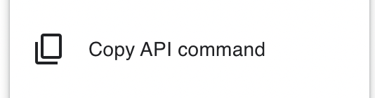

Here is the api command: kaggle datasets download -d yelp-dataset/yelp-dataset

1. I use this command to download the data to S3 Bucket: kaggle datasets download --quiet -d yelp-dataset/yelp-dataset -p - | aws s3 cp - s3://project-yelp-review-sentiment-analysis / yelp-dataset.zip
2. I checked $ aws s3 ls s3:// project-yelp-review-sentiment-analysis/ to see if my data was downloaded.

This is the result I got:

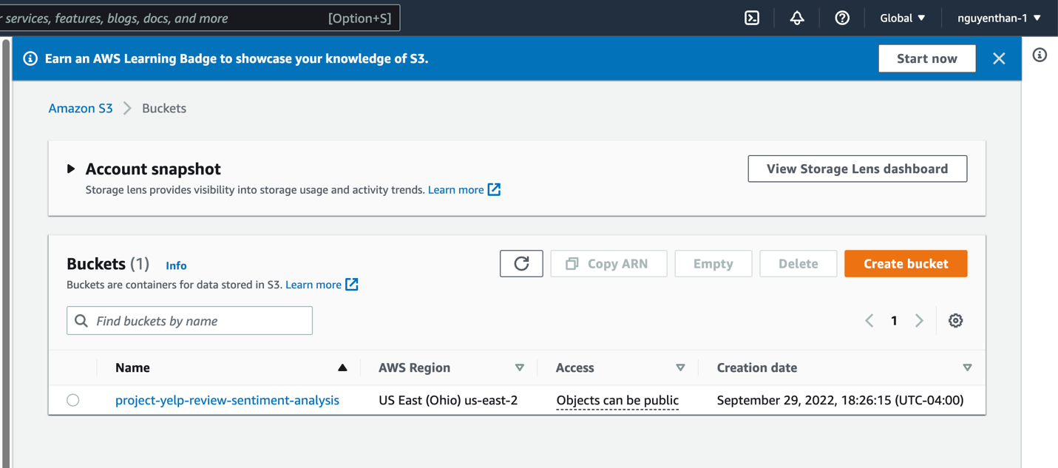

Milestone 3

First step I use this code to unzip the file:   
import zipfile

import boto3

from io import BytesIO

bucket=" project-yelp-review-sentiment-analysis "

zipfile_to_unzip="yelp_dataset.zip"

s3_client = boto3.client('s3', use_ssl=False)

s3_resource = boto3.resource('s3')

# Create a zip object that represents the zip file

zip_obj = s3_resource.Object(bucket_name=bucket, key=zipfile_to_unzip)

buffer = BytesIO(zip_obj.get()["Body"].read())

z = zipfile.ZipFile(buffer)

for filename in z.namelist():

print('Working on ' + filename)

resource.meta.client.upload_fileobj(z.open(filename), Bucket=bucket, Key=f'{filename}')

Number of files unzipped: 5

The format of the file is json, the primary file of data I used it: yelp_academic_dataset_review.json. Here is the code I use to read this file from S3 Bucket. This is the part where I struggle the most and it took a lot of time to get this right.

>>> import json

>>> import boto3

>>> bucket="project-yelp-review-sentiment-analysis"

>>> zipfile_to_unzip="yelp_academic_dataset_review.json"

>>> s3_client = boto3.client('s3', use_ssl=False)

>>> s3_resource = boto3.resource('s3')

>>> data = s3.get_object(Bucket=bucket, Key=zipfile_to_unzip)

>>> json_data = data['Body'].read().decode('utf-8')

I focus mostly on the review dataset and here is the information I found.

Length of the data: 5341423261l

List of variables = ['review_id', 'user_id', 'business_id', 'stars', 'useful', 'funny', 'cool', 'text', 'date']

Review IDs = 6,990,280 unique values (Not numeric)

User ID = 1,987,929 unique values (Not numeric)

Business ID = 150,346 unique values (Not numeric)

Stars = 5 unique values

Numeric, takes 5 values= 1, 2, 3, 4, 5 (no missing value it seems)

Min = 1

Max = 5

Mean=3.75

Std=1.47

Usefuls = 259 unique values including - 1

Numeric, min value= -1, max value = 1182, Avg=1.18, Std=3.25

Assuming value of -1 indicates missing then

* 4 missing values and data below ignores missing values
* Min=0, Max=1182, Avg=1.18, Std=3.25

Funny = 201 unique values including -1

Numeric, min value=-1, max value = 792, Avg=0.3265, Std=1.69

Assuming value of -1 indicates missing value then 2 missing values

Min value =0, Max value = 792, Avg=0.3265, Std=1.69

Cools = 210 unique values including -1

Numeric, min value=-1, max value=404, Avg=0.50, Std=2.17.

Assuming value of -1 indicates missing value then 1 missing values and

Min value=0, Max=404, Avg=0.50, Std=2.17

Text = 6,974,127 unique values

Not numeric

All 6,990,280 texts are non empty

Date = 6,885,665

Not numeric, min value=2005-02-16 03:23:22, Max=2022-01-19 19:48:45

In summary in this part of the doing descriptive statistic, I face many challenges. First of all this is json file and a lot of pandas related packaged did not work for me and the project being killed a lot of time in the process so I have to repeat the code using to get the json file from s3 bucket to EC2 instance quite sometimes. I believe next time when I come back to the project I need to make the instance bigger. The second part is it take a lot of time to load in package like nltk and regex so it is quite time consuming in doing a deeper analysis related to this data.

Milestone 4

Coding and Modeling:

In this milestone what I did was generated an EMR cluster and attached it to a notebook and wrote my code on that notebook.   
This processed was quite hard as for I have some issue starting the EMR and attached it to the EMR notebook where I wrote my code on. Here is what my code looks like

First I read in the data:

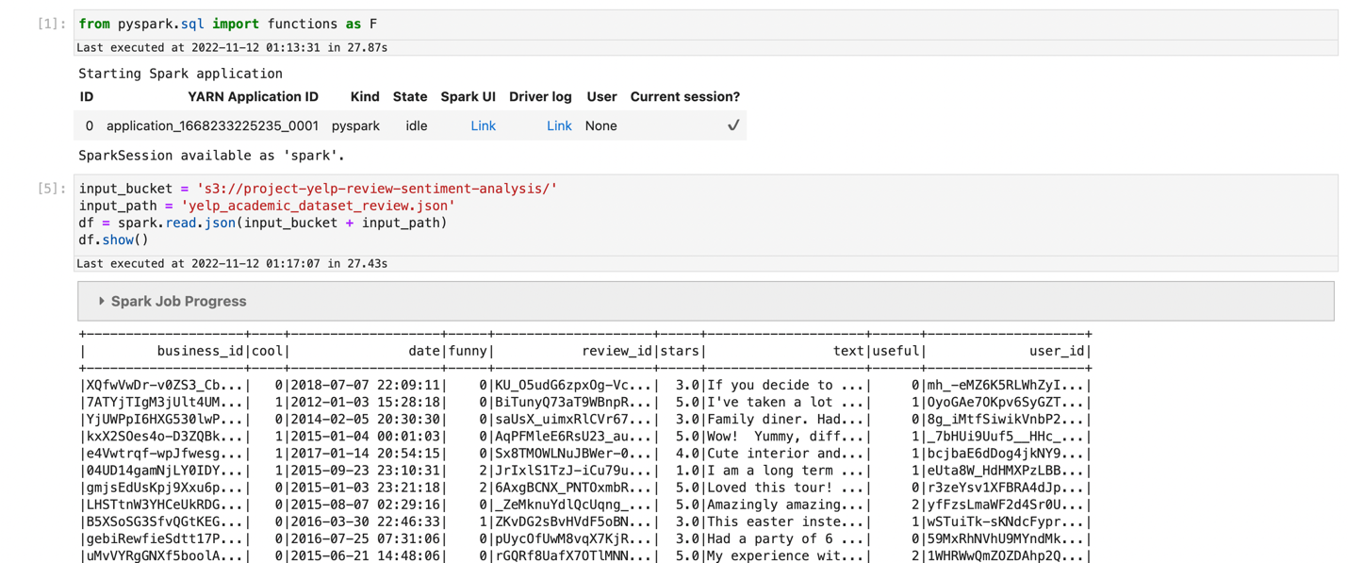

Second step: I process the data by tokenization, and remove stop words

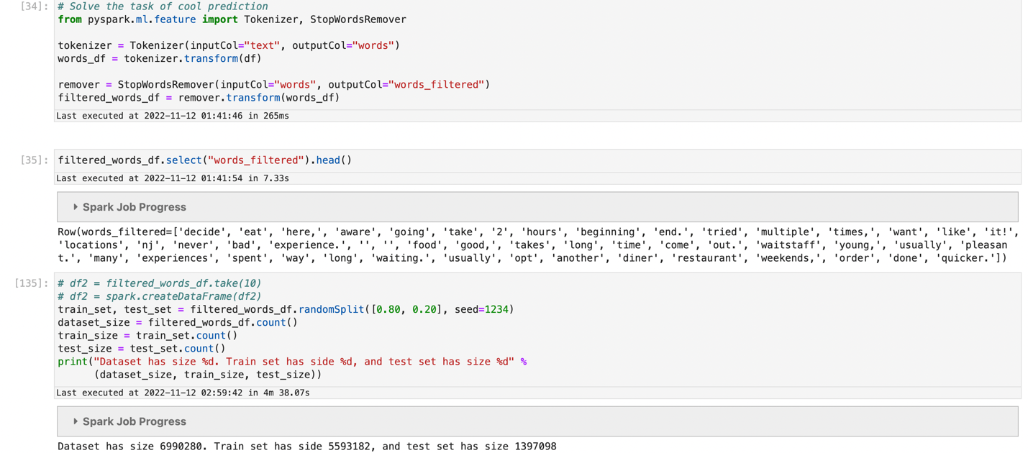

Third step: I get the size of the vocabulary and split and train my data

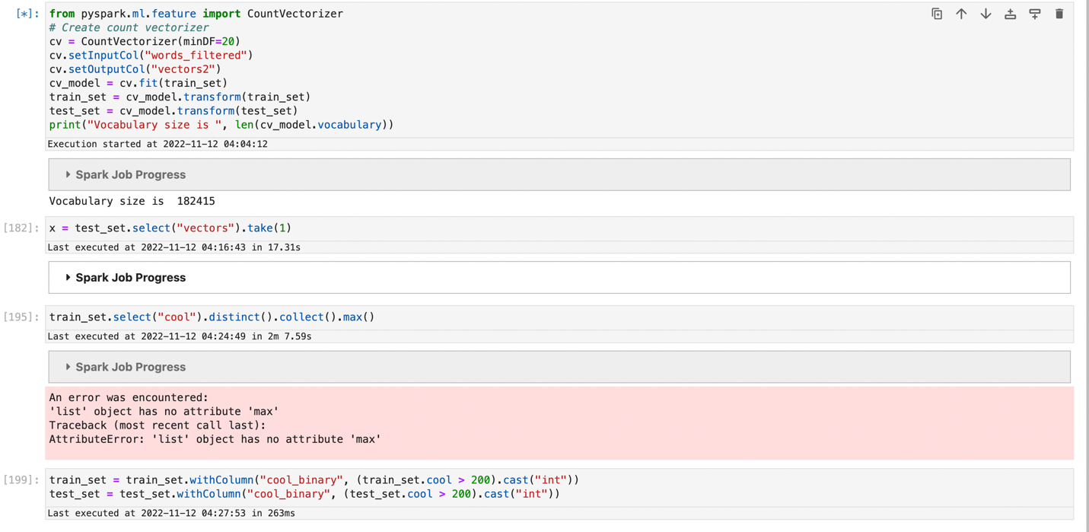

Fourth step: I train the model using logistic regression.   
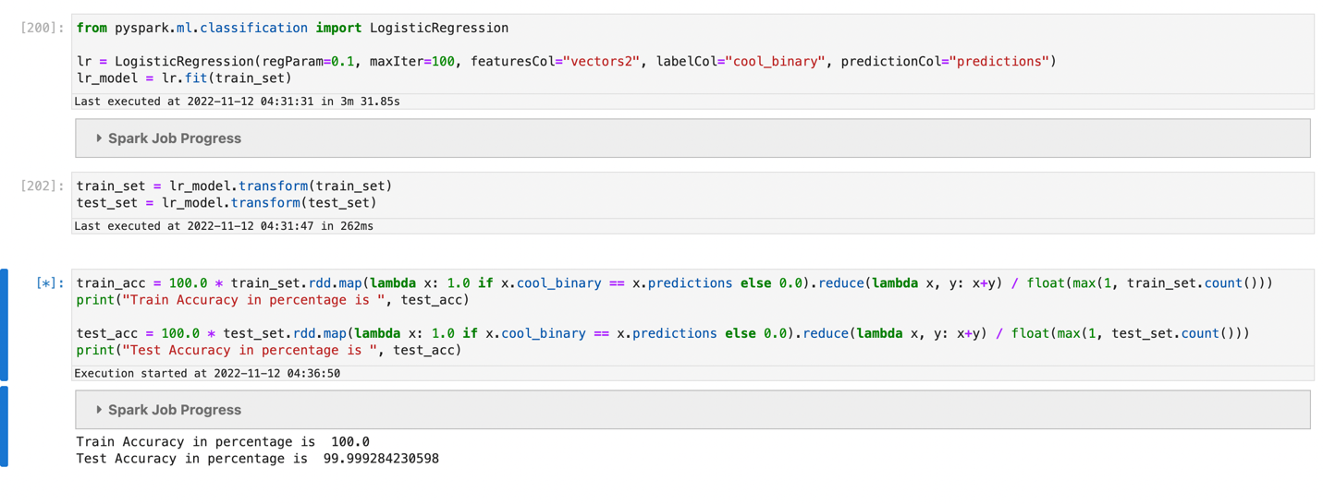

The struggle I got here was learn how to do NLP with Spark because the one in DataCamp course did not really offer with this specific section. So I did intensive googling and read off a lot of stackoverflow questions and problems. This has been slowing me back a lot.   
Another struggle I encountered was to generate the notebook from EMR notebook, it took me quite a lot of trial and errors.

My final struggle was I was not able to merge this dataset and the rating dataset which prevented me from getting sentiment scores I was not able to really do all the sentiment analysis for this reviews.

Milestone 5

In this milestone changed my sentinent analysis to using IDF + hashing TF + Logistic Regression and CountVectorizer + IDF + Logistic Regression.   
Prior to this process I use tokenize the text column and used binarizer to binarize the stars rating for the review with threshold of 3 to classified the sentiments. With 1 to 3 to 0 and 4, 5 to 1 with 0 is negative sentiment and 1 to be positive sentiment.   
Another necessary step I think worked for me was to split train and testing dataset prior sentiment analysis and prediction of either sentiment is negative or positive

IDF + hashing TF + Logistic Regression code:

After tokenize I use, hashing TF, idf, and string indexer and combine all of them into a pipeline, and fit the pipeline with the training data set.   
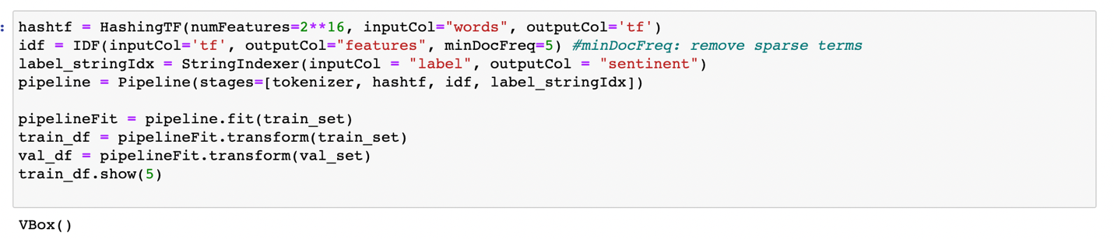

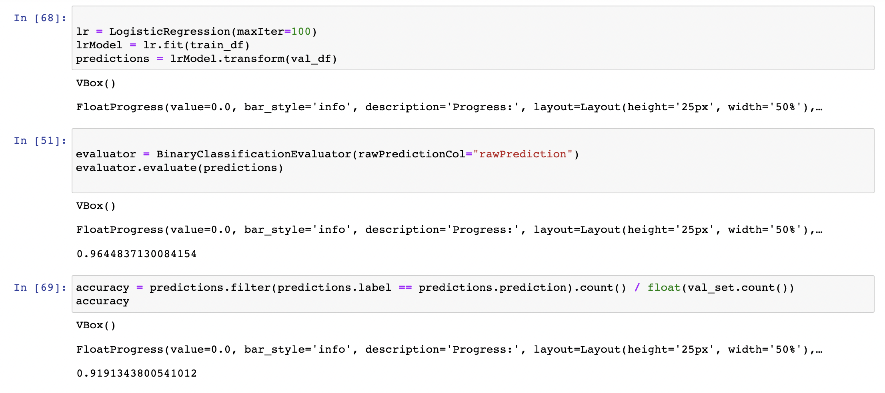

I check the accuracy and the model produce a results of 91%

CountVectorizer + IDF + Logistic Regression.   
I check with using CountVectorizer and IDF to see if there is any change in 2 methods, I don’t see much change between these 2 methods in term of accuracy.

Same with the previous step I use, CountVectorizer, idf, and logistic regression and combine all of them into a pipeline, and fit the pipeline with the training data set.

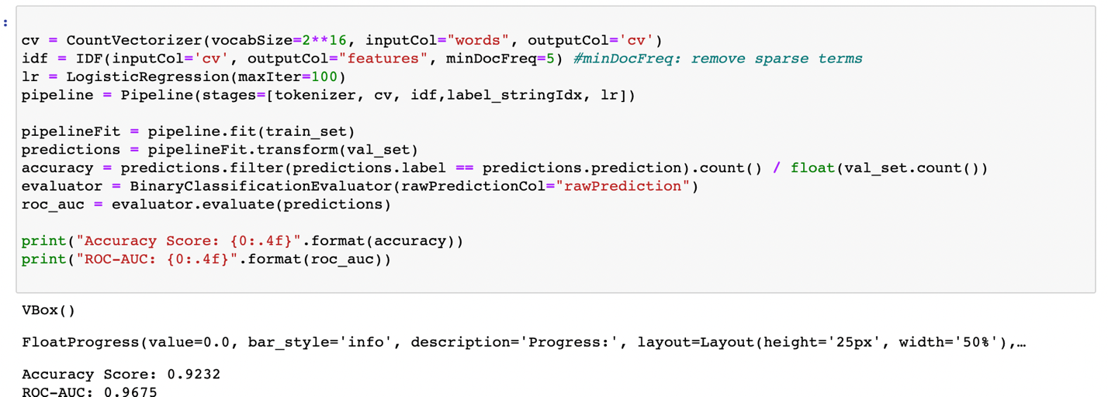

Topic Modeling

I struggle quite a lot with topic modeling with pyspark the reason was it took a lot of time to produces the result for topic modeling, however, I was able to use the previous code written on count vectorization and IDF feature to connected these two with spark LDA to produce topic modelling.

Here is the code for topic modeling in the next page

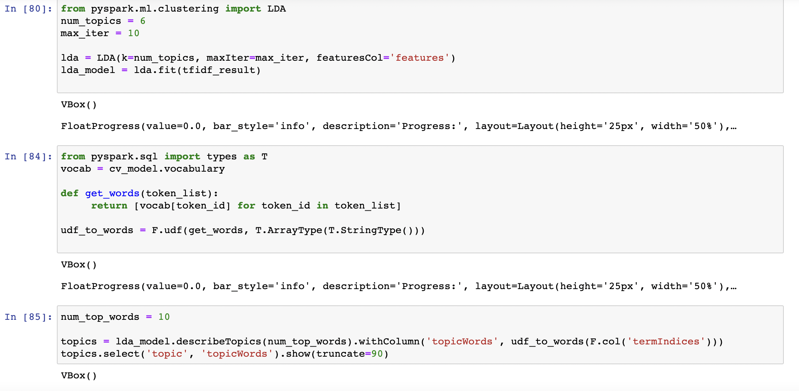

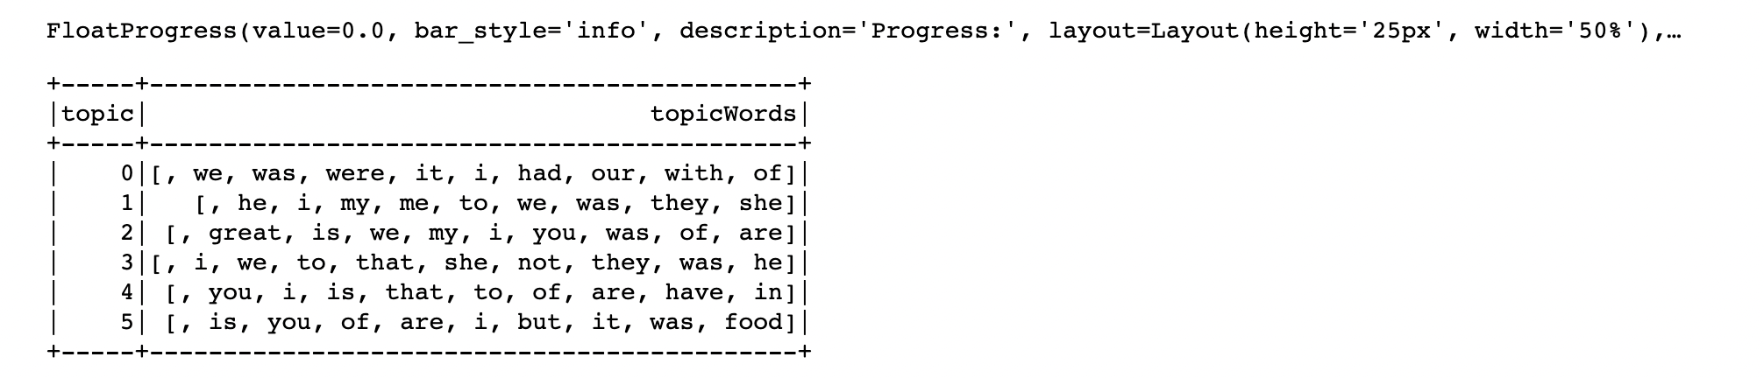

Data visualization

A visualization of the sentiment from the review of the dataset.

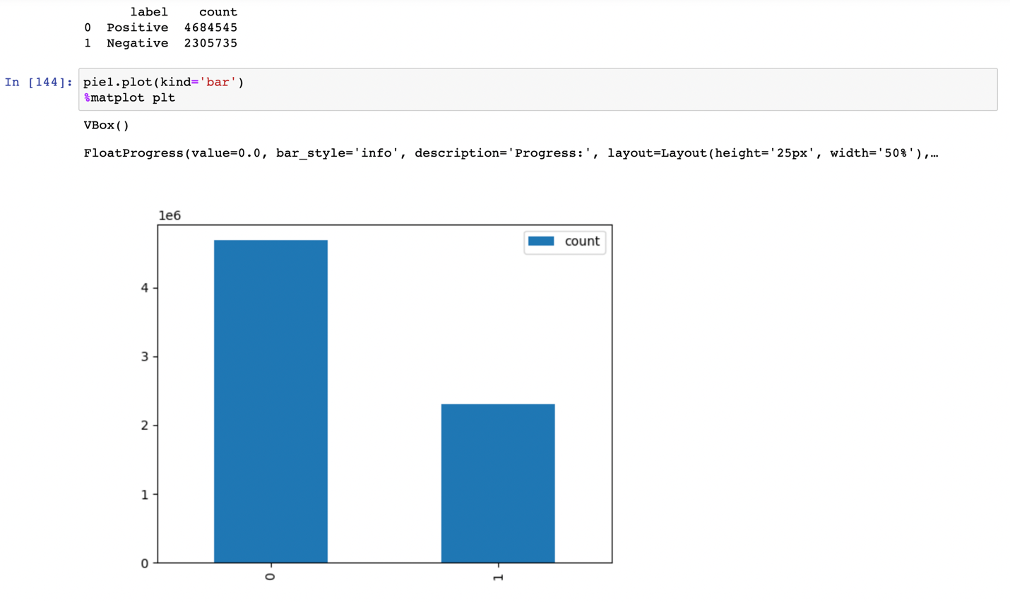

I did not see a lot of information I can do for data visualization on the review dataset for dataset so I use the business dataset to perform data visualization through data exploratory using jupyter notebook, with library like matplotlib, seaborns, and worldcloud.

Here are some results I found.

Data information:

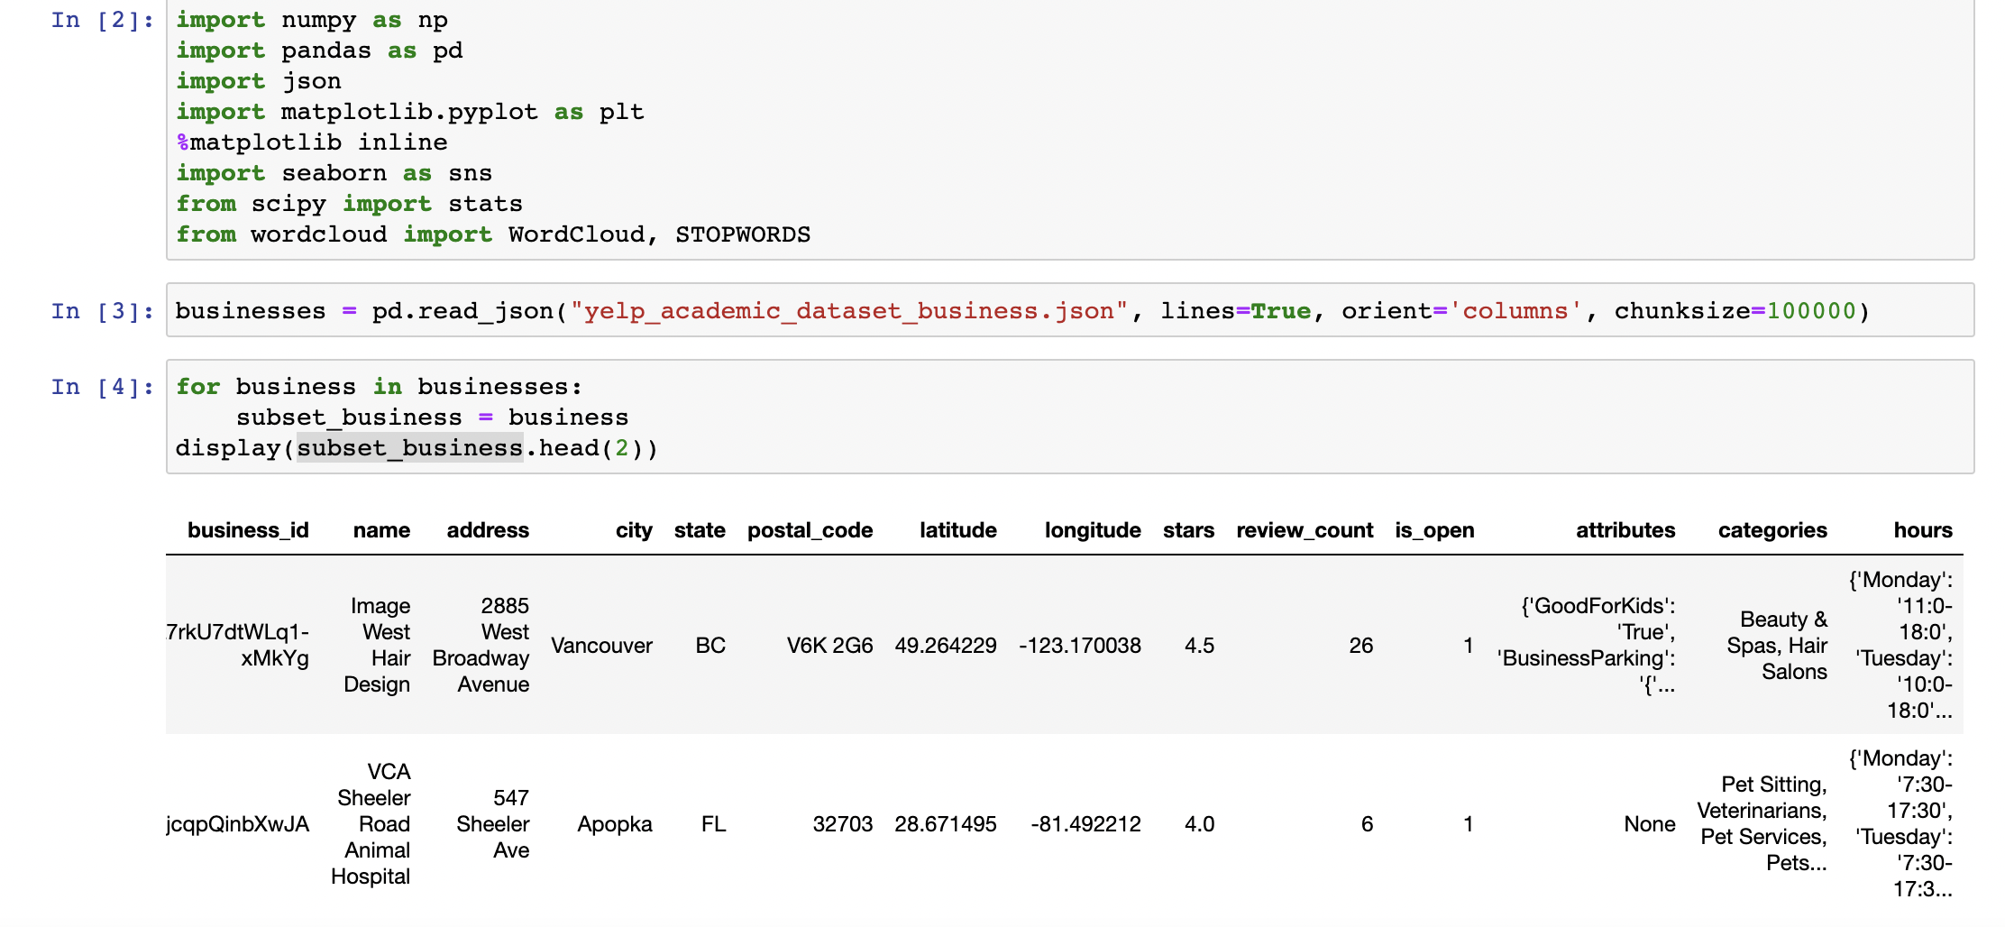

Data shape: 

Top categories visualization

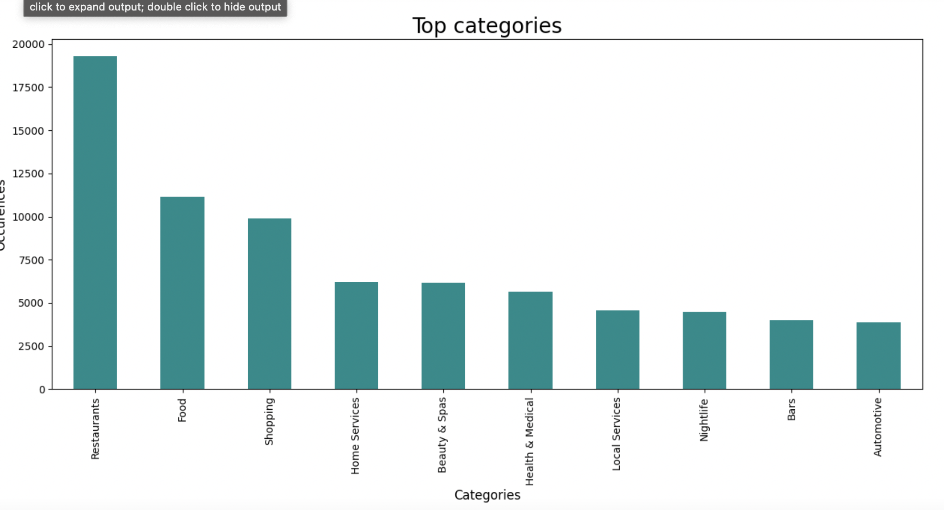

Distribution of customer rating

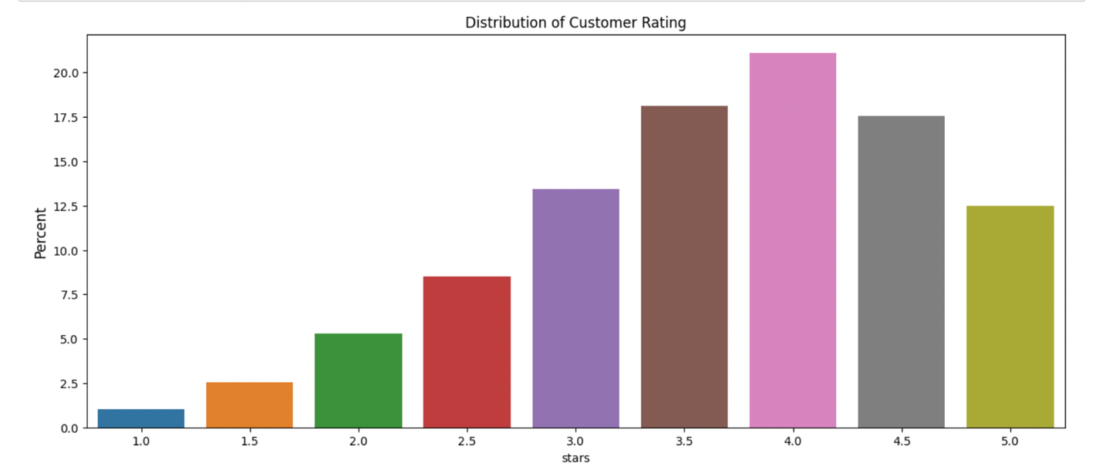

Top cities with the most restaurants

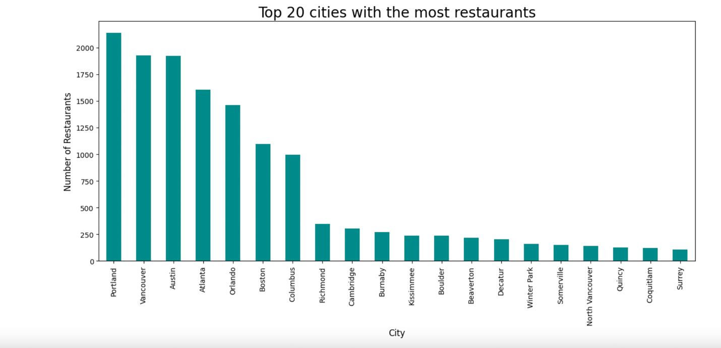

Top cities with most Italian restaurants

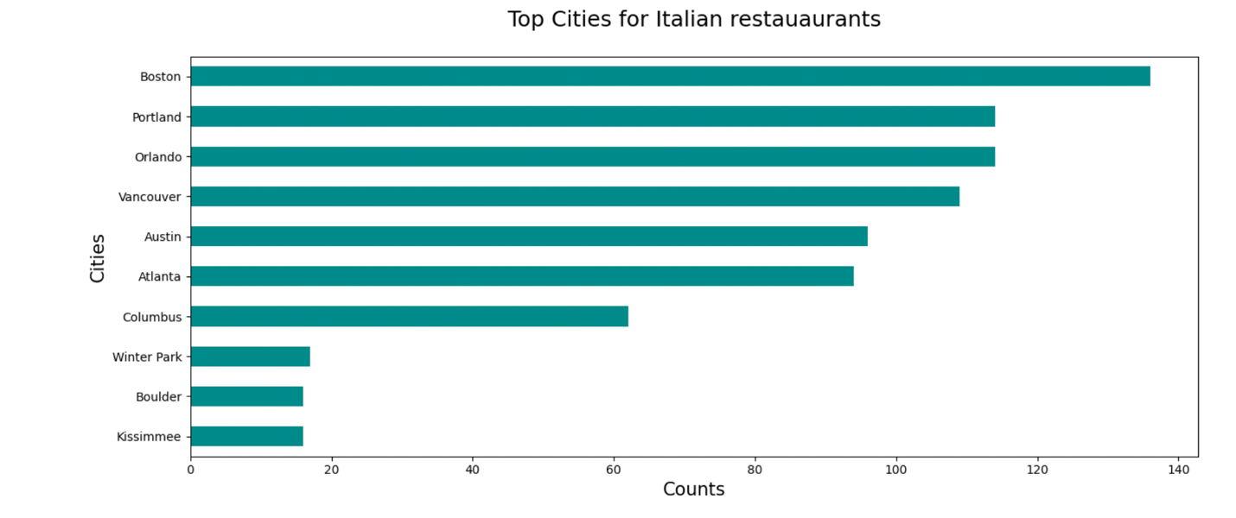

Location of the Boston Italian restaurants

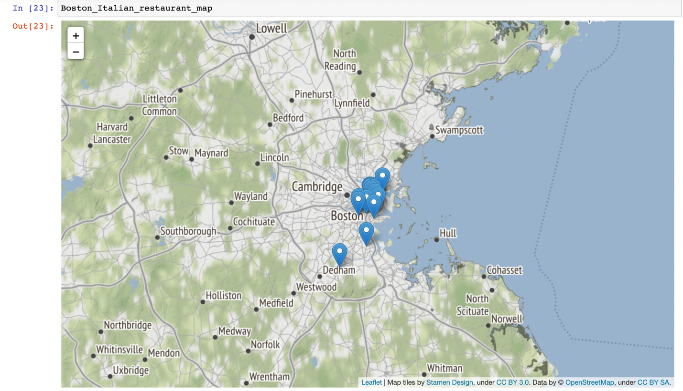

Worldcloud of the categories data

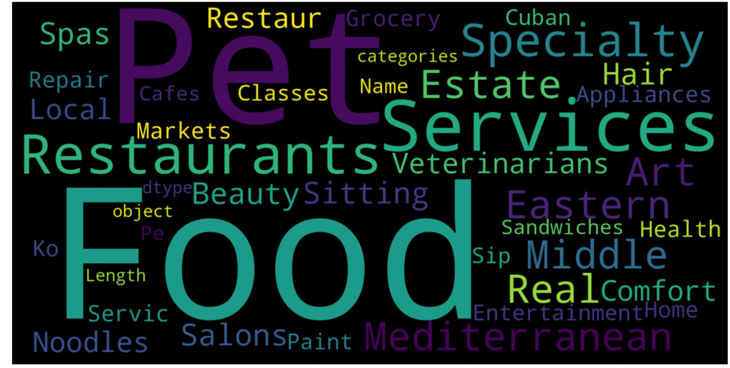

Milestone 6

In this project I mostly use pipeline in 2 parts of doing sentiment analysis with logistic regression in milestone 5 code. My conclusion for this project is the 2 method of sentiment analysis produces somewhat similar result with accuracy of: 91% and 96%.

In the data I found that there are more positive reviews than negative reviews, and reviews are occupied around 3.5, 4 and 4.5 stars. The most popular categories are: restaurants, food, shopping and home services,.. . I look into the Italian restaurant categories I found out that the place that has highest number of Italian restaurants is in Boston instead of cities in the tri state area. Another interesting point I found out is that the city with the most restaurant is Portland.

Milestone 7

Github URL:

<https://github.com/nguyenthan-1/CIS-4130-Semester-Project>

Citation

Sentiment Analysis with PySpark

<https://towardsdatascience.com/sentiment-analysis-with-pyspark-bc8e83f80c35>

Visualization on Yelp Dataset

<https://www.kaggle.com/code/ibadia/visualization-on-yelp-dataset>

Data Viz, EDA on Yelp(Restaurants)

https://www.kaggle.com/code/zolboo/data-viz-eda-on-yelp-restaurants